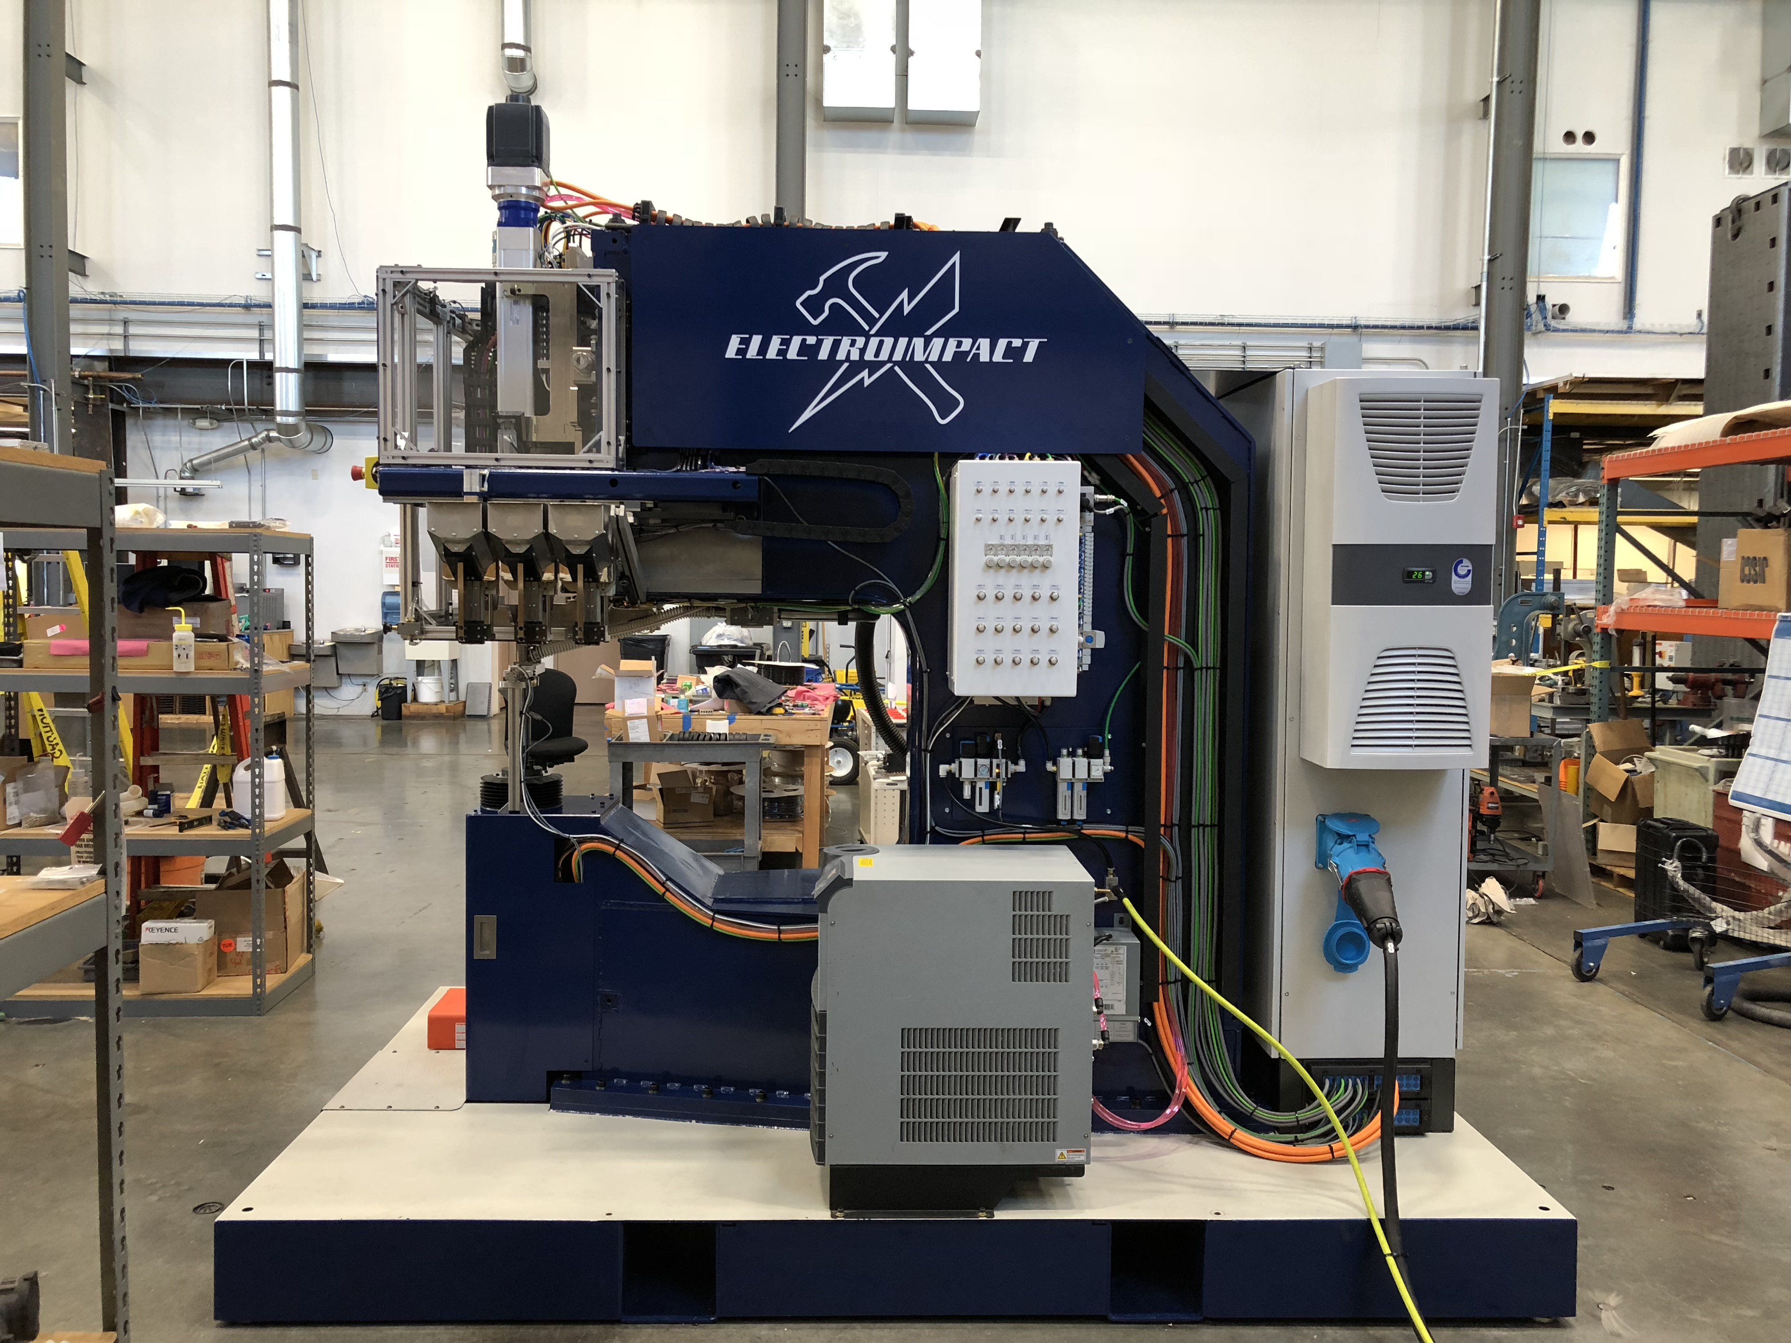
Lower Ram All Electric
Clampup pneumatic adjustable 0-1200 lbf. Clear opening is 150mm with lower tool in place.
Load cell to control and measure upset
Roller screw servoed 18 kip max, stroke 180mm, can install 5/16 dia 2017 rivets and ¼ dia 7050 rivets
Lower tool two 16mm bolt attachment, becomes solid for bolt insertion, manual rotation

Upper Ram All Electric
Matching roller screw to lower for bolt insertion up to 5/8, stroke 150mm
Ram rotates 30 degrees to accept the rivet
Electroimpact patented air gap sensor to prevent panel damage from laid down rivets
Upper riveting tool attaches with Schunk Vero. Pushbutton release.

Upper pressure foot bushing
Moving upper pressure plate 10mm stroke
Bushing height 50mm
Manual rotation

Spindle All Electric
Drill spindle is Fischer SD60124 with pneumatic drawbar for HSK40.
Spindle provides 10 Ntm continuous torque to HSK40 tooling. Can drill 3/4” in aluminum.
Spindle is liquid cooled.
Max RPM 18000
Spindle stroke is 110mm
Boelube headstone spray lube
Chip blower

C-Frame
Throat Depth 1.1m. Will be adjusted to meet your requirements.

Controls
Siemens PLC
Power 400VAC 3ph

Unique and Flexible Hopper Feed System

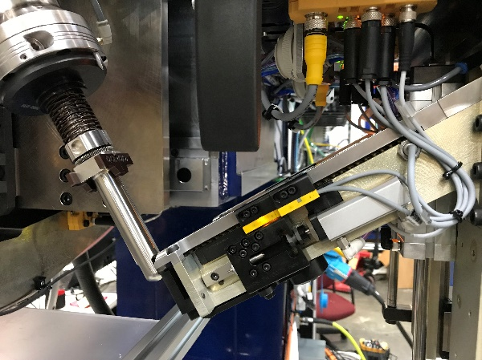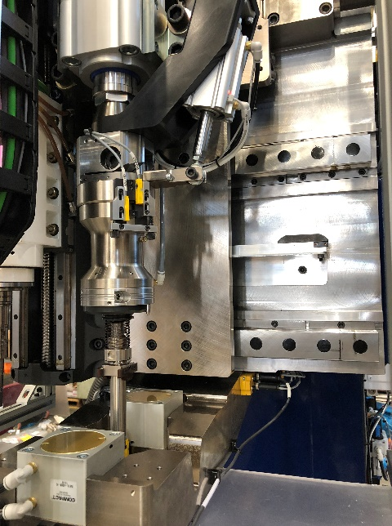

Fingers rotates to a 30 degree angle to match the hopper ramp angle.
Minimum grip rivet that can be fed is 4.5 (0.28”). Fastener feed is not impeded by reverse shingling due to the in-line injection feature.
Maximum length of bolt that can be fed is two inch pintail.
Hopper changer allows six different hoppers to be mounted and manually or auto selected.
See the wide variety of fasteners that can be automatically fed and installed below.

Positioning
Laseraim laser dot
Push pedal to insert fastener

Chip Vacuum
Dry vacuum
Shutoff valve to allow Boelube spray

Cost
Cost to purchase is $500,000 complete with tooling
Less than the cost to refurb an old-fashioned hydraulic riveter.
Lease to own
